**EXP NO: 03 DATE: 13-03-24**

**Aim:**To Create a simple cloud software application for Car Booking Reservation System using any Cloud Service Provider to demonstrate SaaS include the necessary fields such as search for cabs, from, to, rental , out station, Package type, hours/Days etc.

**Implementation:**

1.Go to Zoho.com and login/signup

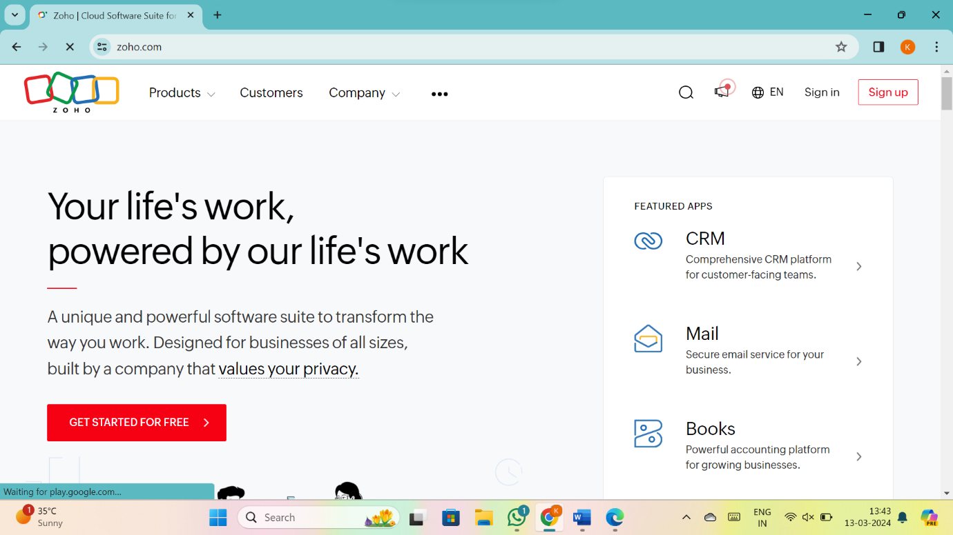

2.Go to Creator

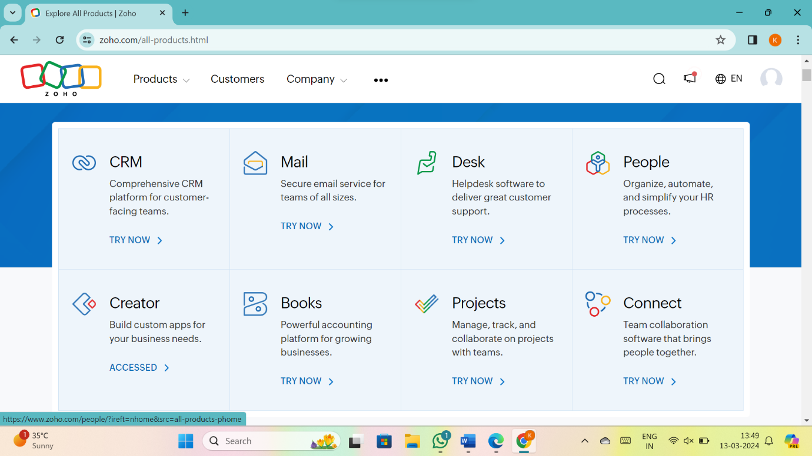

3. CREATE NEW APPLICATION

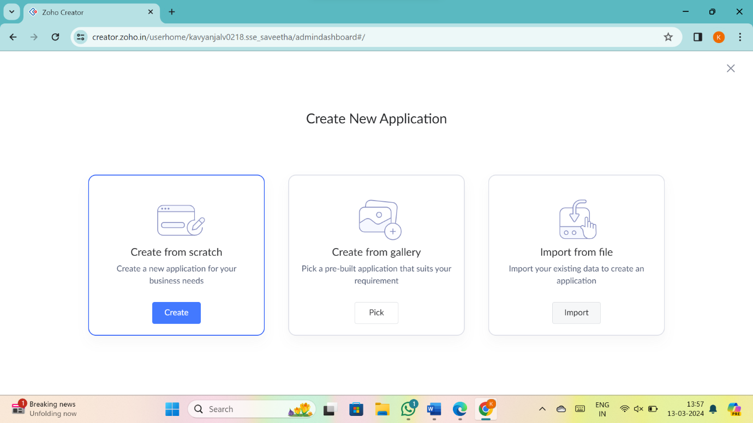

4.Give Application Name

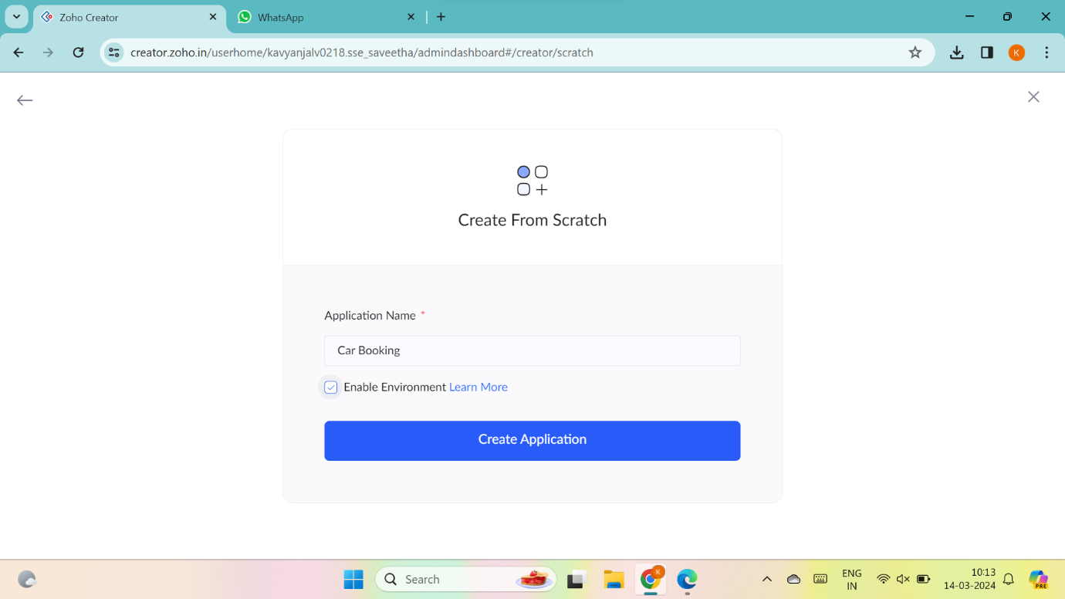

5.Create New Form

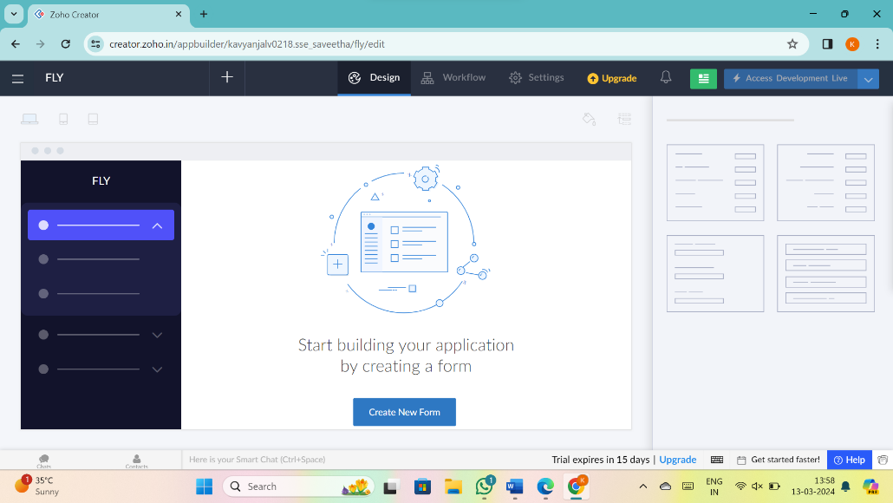

6.Select Form and give name

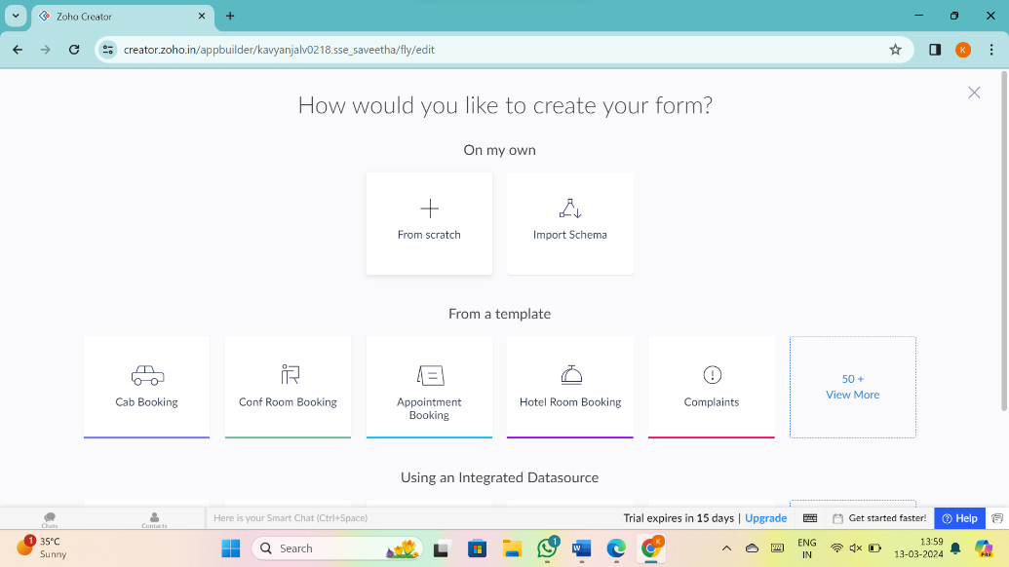

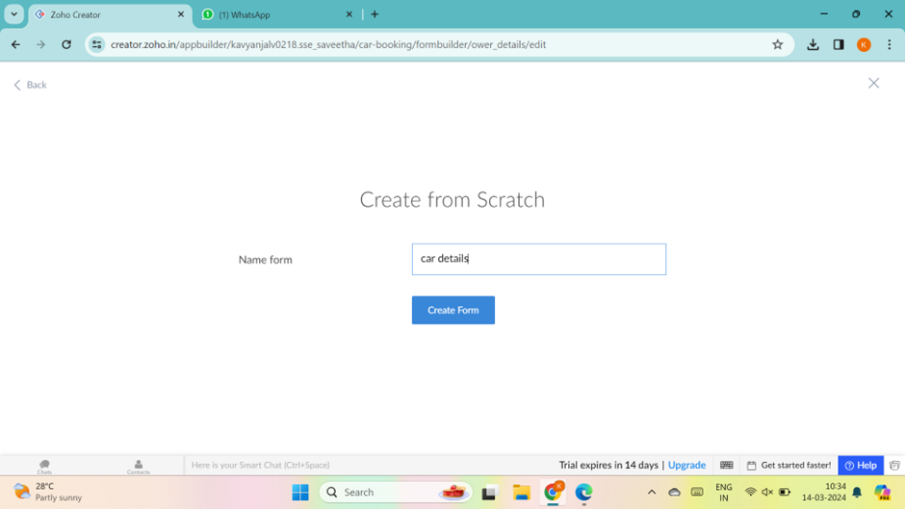

7.Drag necessary fields

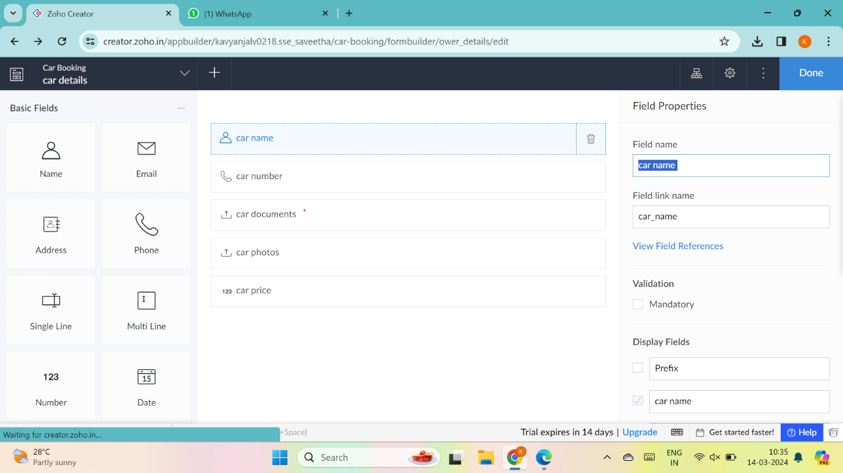

8.create new forms if necessary

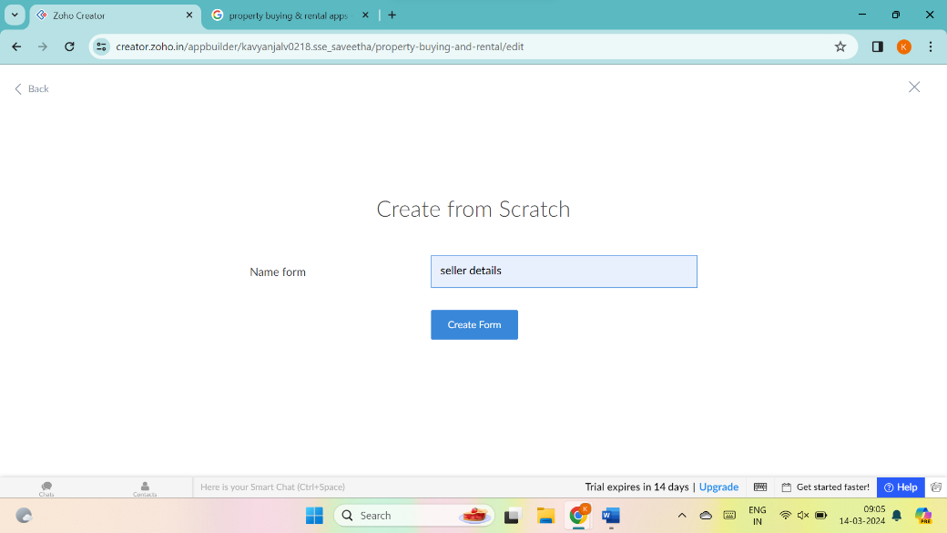

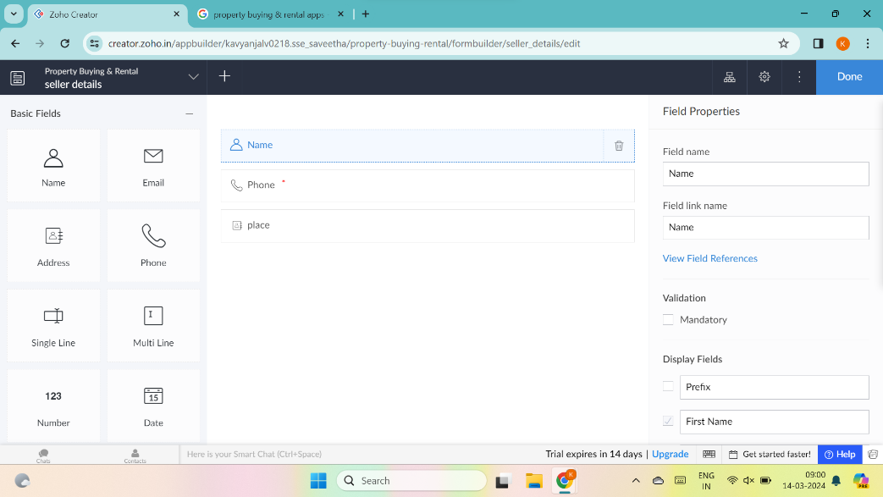

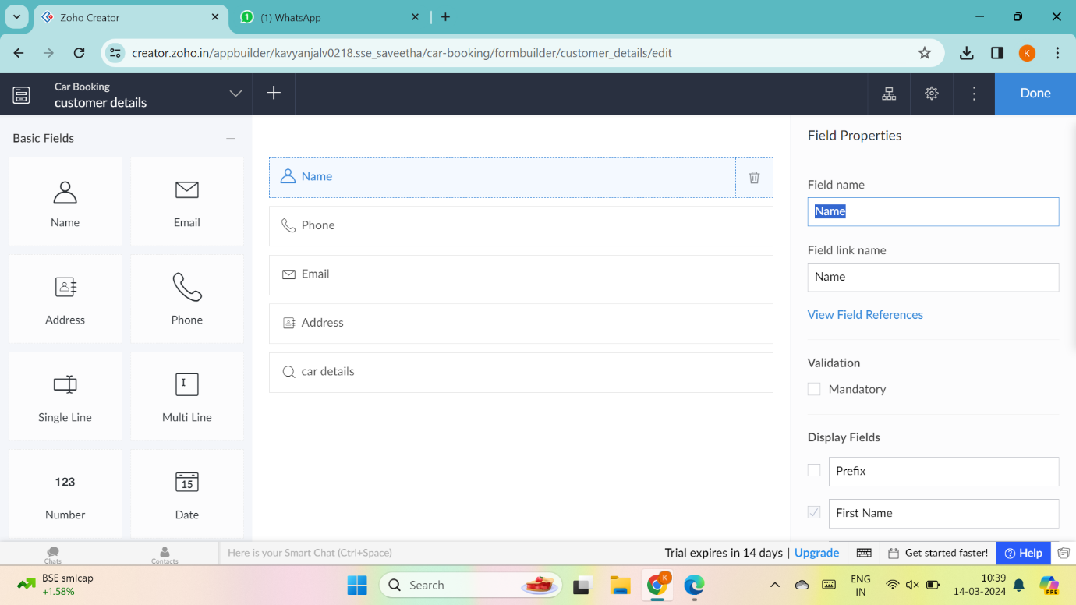

9.The software has been created

